**MINI PROJECT**



ON

**“TOURS AND TRAVELS WEBSITE"**

Submitted for the degree of **B.E. (Computer Engineering)**  **BY**

Dhiraj R. Manje ROLL NO.21

**UNDER THE GUIDANCE OF**

Prof. Satish J. Manje



**DEPARTMENT OF COMPUTER ENGINEERING** SHIVAJIRAO S. JONDHLE COLLEGE OF ENGINEERING AND TECHNOLOGY,

ASANGAON 421601. UNIVERSITY OF MUMBAI 2020-21

**Table of Contents**

|  |  |  |
| --- | --- | --- |
| **Chapter No.** | **Chapter** | **Page No.** |
| 1. | Introduction | 3 |
| 2. | Problem Statement | 4 |
| 3. | Existing System | 5 |
| 4. | System Architecture | 8 |
| 5. | Module Information | 7 |
| 6. | Advantages | 17 |
| 6. | Conclusion | 18 |
|  | Future Scope | 19 |

1. **INTRODUCTION**

The Tours and Travel Management System is a web based application. The main purpose of “Tours and travels management system” is to provide a convenient way for a customer to book hotels, flight, train and bus for tour purposes. The objective of this project is to develop a system that automates the processes and activities of a travel agency. In this project, we will make an easier task of searching places and for booking train, flight or bus. . In the present system a customer has to approach various agencies to find details of places and to book tickets. This often requires a lot of time and effort. We provide approach skills to critically examine how a tourist visits and its ability to operate in an appropriate way when dealing with the consequences of tourism, locally, regionally, and nationally including visitor security and ecological influences. It is tedious for a customer to plan a particular journey and have it executed properly. The project ‘Tours and Travels Management System’ is developed to replace the currently existing system, which helps in keeping records of the customer details of destination as well as payment received.

This application is develop to provide best travelling services to the customers and travel agents. We have developed tours and travel management system to provide a search platform where a tourist can find their tour places according to their choices. This system also helps to promote responsible and interesting tourism so that people can enjoy their holidays at their favorable places. This system also helps to develop tourism with different cultures so that they enrich the tourism experience and build pride. We develop this system to create and promote forms of tourism that provide healthy interaction opportunities for tourists and locals and increase better understanding of different cultures, customs, lifestyles, traditional knowledge and believe. This system also provides a better way to connect with various events.  
  
This system also gives tours related information like which places are tourist attractions, cities, and provinces. Tourist can also get the Map and navigation system and temperature and weather information. Tourist can also book tours through our tours and travels management system. This system also keeps a history of visited places of its users.

1. **PROBLEM STATEMENT**



India is a country where in a few days holiday, you can enjoy a lot .The problem is that we although having many websites but they offer different kind of services .The customers are enjoying a lot but there is a lack of relationship between travel agency and customers and hence we are establishing that relationship by caring and serving all customers in the same manner that we wish to be served. The purpose of website is established fact that Internet users are increasing today.

One of the main purposes of the website is to facilitate the offline customer online because customers cannot spend their precious time in markets trying to find out the best deal. We will be putting an effort to provide the right choice to the people when they plan a holiday and beware them from the false advertising.

1. **EXISTING SYSYTEM**

Nearly everyone goes on a vacation and a Tourism management system would play a vital role in planning the perfect trip. The tourism management system allows the user of the system access all the details such as weather, location, events, etc. The main purpose is to help tourism companies to manage customer and hotels etc. The system can also be used for both professional and business trips. The proposed system maintains centralized repository to make necessary travel arrangements and to retrieve information easily.

• The system is implemented in Oracle

• Normalization and Dependencies are handled

• Queries useful for the user of the database

• The Queries are translated into relational algebra



1. **SYSTEM ARCHITECTURE**

**User Interface**

**Flight, Hotel Booking**

**Response**

**Feedback**

**Database Server**

**USER**

1. **MODULE INFORMATION**
   1. **SYSTEM OVERVIEW**

‘Tours and travels’ website is mainly consists of six different web-pages, where every web-page having its own importance. the website designed is very user-friendly and highly interactive and gives great experience to user. There are various services available for user. The services are as follows:

* Book flight, hotels
* Car-rental
* VISA service
* Register for bus, trains

The website also provides a feedback option for user to know the opinion and experience of user about the services. The gallery page is created where user can glance the best location for visit.

* 1. **TECHNOLOGY USED**

HTML,CSS & JAVASCRIPT:

The HyperText Markup Language, or HTML is the standard [markup language](https://en.wikipedia.org/wiki/Markup_language) for documents designed to be displayed in a [web browser](https://en.wikipedia.org/wiki/Web_browser). It can be assisted by technologies such as [Cascading Style Sheets](https://en.wikipedia.org/wiki/Cascading_Style_Sheets) (CSS) and [scripting languages](https://en.wikipedia.org/wiki/Scripting_language) such as [JavaScript](https://en.wikipedia.org/wiki/JavaScript).[Web browsers](https://en.wikipedia.org/wiki/Web_browser) receive HTML documents from a [web server](https://en.wikipedia.org/wiki/Web_server) or from local storage and [render](https://en.wikipedia.org/wiki/Browser_engine) the documents into multimedia web pages. HTML describes the structure of a [web page](https://en.wikipedia.org/wiki/Web_page) [semantically](https://en.wikipedia.org/wiki/Semantic_Web) and originally included cues for the appearance of the document.

Cascading Style Sheets (CSS) is a [style sheet language](https://en.wikipedia.org/wiki/Style_sheet_language) used for describing the [presentation](https://en.wikipedia.org/wiki/Presentation_semantics) of a document written in a [markup language](https://en.wikipedia.org/wiki/Markup_language) such as [HTML](https://en.wikipedia.org/wiki/HTML).[[1]](https://en.wikipedia.org/wiki/CSS#cite_note-1) CSS is a cornerstone technology of the [World Wide Web](https://en.wikipedia.org/wiki/World_Wide_Web)

JS, is a [programming language](https://en.wikipedia.org/wiki/Programming_language) that conforms to the [ECMAScript](https://en.wikipedia.org/wiki/ECMAScript) specification.[[9]](https://en.wikipedia.org/wiki/JavaScript#cite_note-tc39-9) JavaScript is [high-level](https://en.wikipedia.org/wiki/High-level_programming_language), often [just-in-time compiled](https://en.wikipedia.org/wiki/Just-in-time_compilation), and [multi-paradigm](https://en.wikipedia.org/wiki/Programming_paradigm). It has [curly-bracket syntax](https://en.wikipedia.org/wiki/List_of_programming_languages_by_type#Curly-bracket_languages), [dynamic typing](https://en.wikipedia.org/wiki/Dynamic_typing), [prototype-based](https://en.wikipedia.org/wiki/Prototype-based_programming) [object-orientation](https://en.wikipedia.org/wiki/Object-oriented_programming), and [first-class functions](https://en.wikipedia.org/wiki/First-class_function).

BOOTSTRAP:

Bootstrap is a [free and open-source](https://en.wikipedia.org/wiki/Free_and_open-source) [CSS framework](https://en.wikipedia.org/wiki/CSS_framework) directed at responsive, [mobile-first](https://en.wikipedia.org/wiki/Responsive_web_design#Mobile_first,_unobtrusive_JavaScript,_and_progressive_enhancement) [front-end web development](https://en.wikipedia.org/wiki/Front-end_web_development). It contains [CSS](https://en.wikipedia.org/wiki/CSS)- and (optionally) [JavaScript](https://en.wikipedia.org/wiki/JavaScript)-based design templates for [typography](https://en.wikipedia.org/wiki/Web_design#Typography), [forms](https://en.wikipedia.org/wiki/Form_(HTML)), [buttons](https://en.wikipedia.org/wiki/Button_(computing)#HTML), [navigation](https://en.wikipedia.org/wiki/Web_navigation#Local_website_navigation), and other interface components.

* 1. **SOURCE CODE**

Index.html

<!DOCTYPE html>

<html>

<head>

<title>Travelo.com - Flights,Hotels,Car-Rentals</title>

</head>

<meta charset="utf-8">

<link rel = "icon" href ="images/logo3.png" type = "image/x-icon">

<link rel="stylesheet" href="css/style.css">

<link rel="stylesheet" href="css/bootstrap.min.css">

<link href="https://fonts.googleapis.com/css?family=Marcellus+SC&display=swap" rel="stylesheet">

<link href="https://fonts.googleapis.com/css?family=Raleway&display=swap" rel="stylesheet">

<script src="js/jquery.js"></script>

<script src="js/bootstrap.min.js"></script>

<script src="js/all.min.js"></script>

</style>

</head>

<body class="main">

<!--Navigation Bar-->

<header>

<nav class="navbar navbar-expand-lg navbar-light bg-light">

<a class="navbar-brand" href="#"><img class="logo" src="images/logo3.png"><img class="logoname" src="images/logoname.png"></a>

<button class="navbar-toggler" type="button" data-toggle="collapse" data-target="#navbarSupportedContent" aria-controls="navbarSupportedContent" aria-expanded="false" aria-label="Toggle navigation">

<span class="navbar-toggler-icon"></span>

</button>

<div class="collapse navbar-collapse" id="navbarSupportedContent">

<ul class="navbar-nav ml-auto">

<li class="nav-item active">

<a class="nav-link" href="index.html">Home <span class="sr-only">(current)</span></a>

</li>

<li class="nav-item">

<a class="nav-link" href="aboutus.html">About Us</a>

</li>

<li class="nav-item dropdown">

<a class="nav-link dropdown-toggle" href="#" id="navbarDropdown" role="button" data-toggle="dropdown" aria-haspopup="true" aria-expanded="false">

Services

</a>

<div class="dropdown-menu" aria-labelledby="navbarDropdown">

<a class="dropdown-item" href="services.html">Flights</a>

<a class="dropdown-item" href="services.html">Hotels</a>

<a class="dropdown-item" href="services.html">Car-Rentals</a>

<div class="dropdown-divider"></div>

<a class="dropdown-item" href="services.html">More</a>

</div>

</li>

<li class="nav-item">

<a class="nav-link" href="gallary.html">Gallery</a>

</li>

<li class="nav-item">

<a class="nav-link" href="contactus.html">Contact us</a>

</li>

</ul>

</div>

</nav>

</header>

<!--Slider Start-->

<section class="">

<div id="carouselExampleIndicators" class="carousel slide" data-ride="carousel">

<ol class="carousel-indicators">

<li data-target="#carouselExampleIndicators" data-slide-to="0" class="active"></li>

<li data-target="#carouselExampleIndicators" data-slide-to="1"></li>

<li data-target="#carouselExampleIndicators" data-slide-to="2"></li>

</ol>

<div class="carousel-inner">

<div class="carousel-item active">

<img class="d-block img w-100" src="images/slide1.jpg" alt="First slide">

<div class="carousel-caption">

<h1 class="sheading">EXPERIENCE THE BEST TRIP EVER</h1>

<p>We are committed to offering travel services of highest quality by combining our energy & enthusiasm with years of experience. </p>

<button type="button" class="btn btn-outline-light mr-2">More</button>

<button type="button" class="btn btn-warning ml-2">Contact Us</button>

</div>

</div>

<div class="carousel-item">

<img class="d-block img w-100" src="images/slide2.jpg" alt="Second slide">

<div class="carousel-caption">

<h1 class="sheading">DESTINATION VARIETY</h1>

 <p>With us you can reach any point of world map and we will discuss all needed details.</p>

</div>

</div>

<div class="carousel-item">

<img class="d-block img w-100" src="images/slide3.jpg" alt="Third slide">

<div class="carousel-caption">

<h1 class="sheading">EVERYTHING'S ON SHEDULE</h1>

<p>We love punctuality that's why the time of each client trip is sheduled till the last second of adventure.</p>

</div>

</div>

</div>

<a class="carousel-control-prev" href="#carouselExampleIndicators" role="button" data-slide="prev">

<span class="carousel-control-prev-icon" aria-hidden="true"></span>

<span class="sr-only">Previous</span>

</a>

<a class="carousel-control-next" href="#carouselExampleIndicators" role="button" data-slide="next">

<span class="carousel-control-next-icon" aria-hidden="true"></span>

<span class="sr-only">Next</span>

</a>

</div>

</section>

<!--jumbotron-->

<div class="container-fluid">

<div class="row jumbotron">

<div class="d-inline col-xs-12 col-sm-12 col-md-9 col-lg-9 col-xl-10">

<p class="lead text-white btn-warning d-inline">DISCOUNT</p >

<p class="lead">Special offer if you book today; 30% off anywhere in the world with travelo.com</p>

</div>

<div class="col-xs-12 col-sm-12 col-md-3 col-lg-3 col-xl-2">

<a href="" class="btn btn-warning">Register Now!</a>

</div>

</div>

</div>

<!--About Us starts-->

<section class="container-fluid padding m-6">

<br>

<h3 class="heading padding text-center text-justify font-weight-bold">ABOUT US</h3>

<div class="row container-fluid">

<div class="col my-6 col-md-6 col-lg-6 col-sm-12 col-XS-12 text-justify padding">

<p class="main"> Travel doesn’t start when you hit the road, and it doesn’t end when you arrive home.

That’s why at SmarterTravel we deliver expert travel tips, inspiring destination stories,

 and timely travel news to feed your passion for seeing the world before, during, and after your trip.</p>

<p>Since 2013, we’ve worked hard to bring you the most interesting, useful,

and exciting travel information on the Web. </p>

<p>

We’re a team of writers, editors, and developers who love seeing the world and sharing what we find.

Sign up for our newsletters, follow us on Facebook and Instagram, and join us for an amazing journey around the globe.

</p>

<a href="aboutus.html" class="btn btn-warning">Know More</a>

</div>

<div class="col col-md-6 col-lg-6 col-XS-12 col-sm-12 ">

<img src="images/about.jpg" width="100%">

</div>

</div>

</section>

<!--Services Start-->

<Section class="padding" style=" background-image: url('images/background.jpg'); background-repeat: no-repeat; width: 100%;

background-size: cover;">

<div class="container-fluid service padding ">

<br>

<h3 class="heading padding text-center font-weight-bold">SERVICES</h3>

<div class="container">

<div class="row d-flex justify-content-between m-auto">

<!--1st card-->

<div class="padding col-sm-12 col-md-6 col-lg-4">

<div class="card" >

<div class="text-center" >

<i class="fas fa-plane"></i>

</div>

<div id="card2" class="card-body ">

<h5 id="cname" class="card-title heading text-center">FLIGHT</h5>

<p class="card-text">Travel the world with us;you can reach any point of world map.What are you waiting for!</p>

<a href="" class="btn btn-warning">Book Now</a>

</div>

</div>

</div>

<!--2nd card-->

<div class="padding col-sm-12 col-md-6 col-lg-4">

<div class="card">

<div class="text-center">

<i class="fas fa-bed"></i>

</div>

 <div id="card2" class="card-body ">

<h5 id="cname" class="card-title heading text-center">HOTELS</h5>

<p class="card-text">Find the best hotels.Book hotel with us & get the best fares & promotions.We know Hotels - we know Comfort.</p>

<a href="" class="btn btn-warning">Search Hotels</a>

</div>

</div>

</div>

<!--3nd card-->

<div class="padding col-sm-12 col-md-6 offset-md-3 offset-lg-0 col-lg-4">

<div class="card" >

<div class="text-center">

<i class="fas fa-car"></i>

</div>

<div id="card2" class="card-body ">

<h5 id="cname" class="card-title heading text-center">CAR-RENTAL</h5>

<p class="card-text">Special offer if you book today ; 25% off anywhere in world with Travelo.com</p>

<br>

<a href="" class="btn btn-warning">Search Availability</a>

</div>

</div>

</div>

</div>

<!--div class="servbtn">

<button type="button" class="btn col-offset-3 btn-outline-light">More Services</button>

</div-->

</div>

</div>

</Section>

<!--Gallary Starts-->

<section class="container-fluid bg-light">

<br>

<h3 class="heading padding text-center font-weight-bold bg-light">BEST LOCATIONS</h3>

<div class="row ">

<div class="col col-md-4 col-sm-12">

<img class="w-100 padding" src="images/paris.jpg" alt="img1">

<div class="carousel-caption text-left" style ="transform: translateY(25%);">

<p>Paris</p>

</div>

</div>

<div class="col col-md-4 col-sm-12">

<img class="w-100 padding" src="images/malasiya.jpg" alt="img2">

<div class="carousel-caption text-left" style ="transform: translateY(25%);">

<p>Malasiya</p>

</div>

</div>

<div class="col col-md-4 col-sm-12">

<img class="w-100 padding" src="images/london.jpg" alt="img3">

<div class="carousel-caption text-left" style ="transform: translateY(25%);">

<p>London</p>

</div>

</div>

</div>

</section>

<!--Footer Starts-->

<div class="container-fluid pt-4" style=" background-image: url('images/footerbg.jpg'); background-repeat: no-repeat; width: 100%;

background-size: cover;">

<div class="row text-center">

<div class=" logo col-lg-3 col-md-6 col-sm-12">

<div class="col">

<img src="images/logoname.png" width="80" height="40" alt="logo"><br>

<a class="link" href="">Pune</a class="link"><br>

<a class="link" href="">Chennai</a class="link"><br>

<a class="link" href="">Delhi</a class="link"><br>

</div>

</div>

<div class="col">

<a class="link" href="index.html">Home</a><br>

<a class="link" href="aboutus.html">About us</a><br>

<a class="link" href="services.html">Services</a><br>

<a class="link" href="gallery.html">Gallery</a class="link"><br>

<a class="link" href="contactus.html">Contact</a class="link"><br>

</div>

<div class="col-lg-3 col-md-6 col-sm-12">

<h6>Address</h6>

<p>F-07, 1'st Floor,North Block,Sacred World Mall,old Agra road,Thane-411040,Maharashtra,India</p>

</div>

<div class="text-center symbol col-lg-3 col-md-6 col-sm-12">

<h6>Connect with us</h6>

<i class="fab fa-facebook-square"></i>

<i class="fab fa-instagram"></i>

<i class="fab fa-twitter-square"></i>

</div>

</div>

</div>

</div>

<footer class="info text-White bg-warning text-center">

<div>

<strong class="text-White text-center">Copyright &copy; 2019 Travelo.com</strong>

</div>

</footer>

</body>

</html>

* 1. 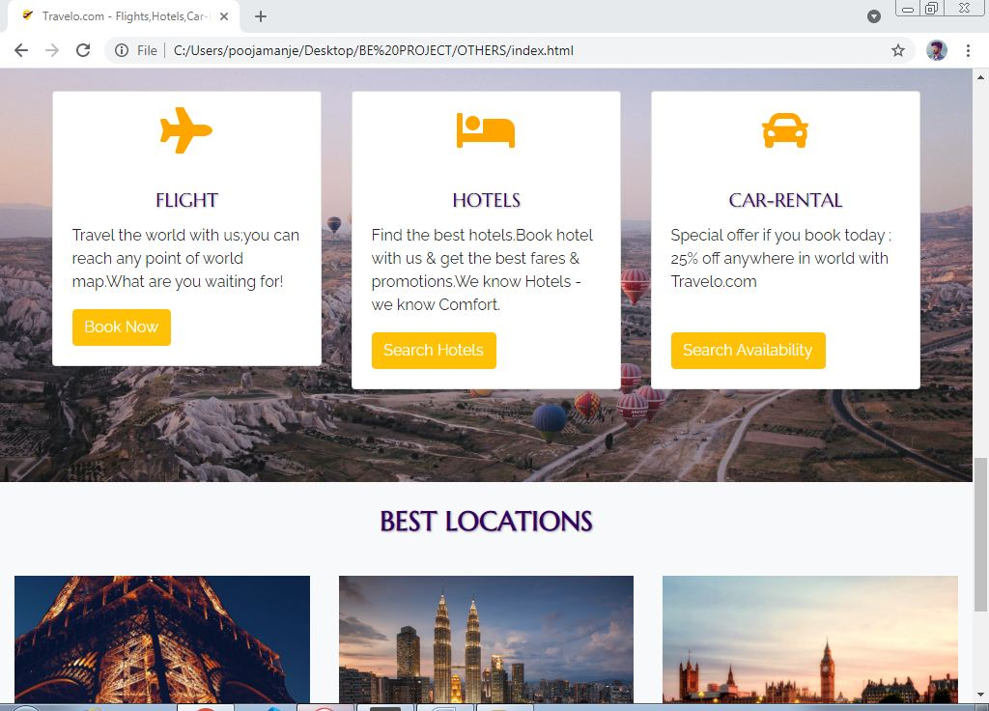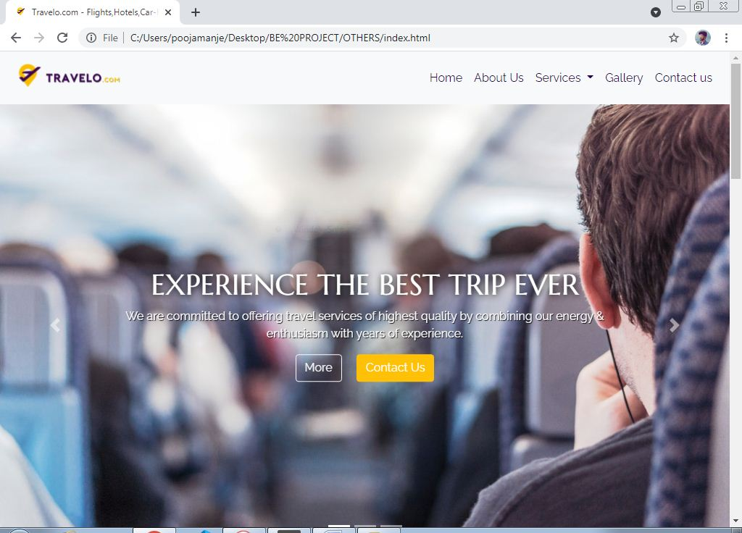**SCREENSHOTS**

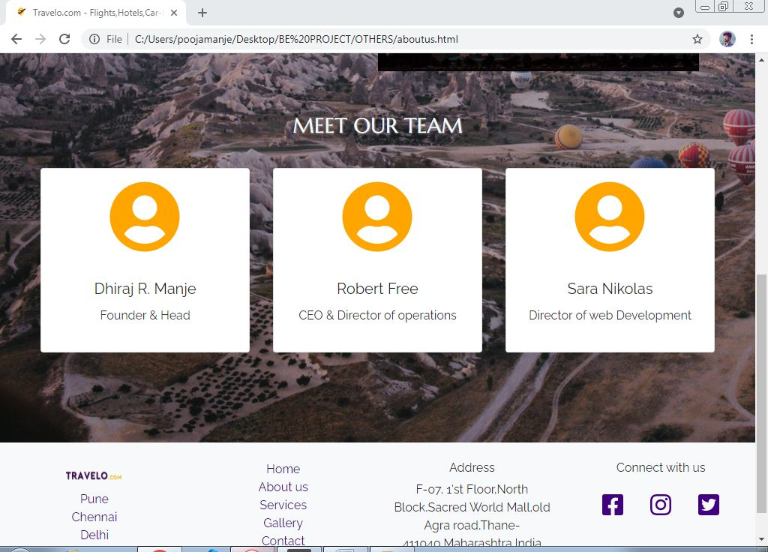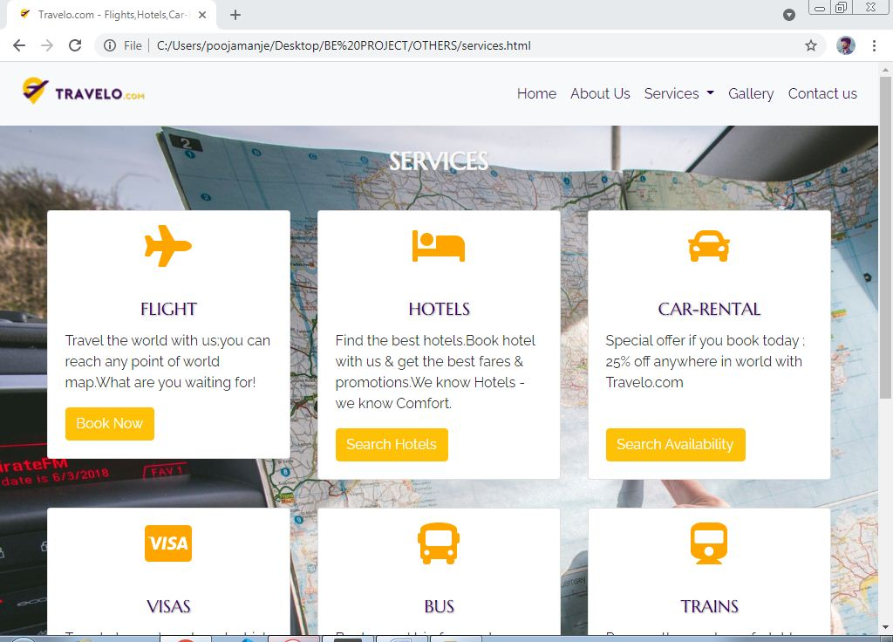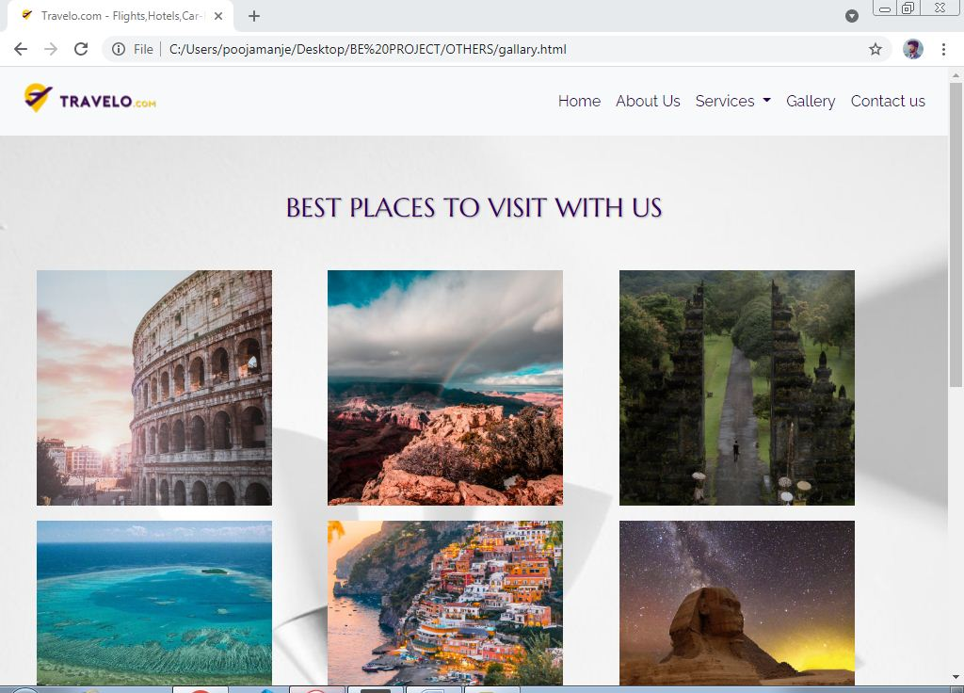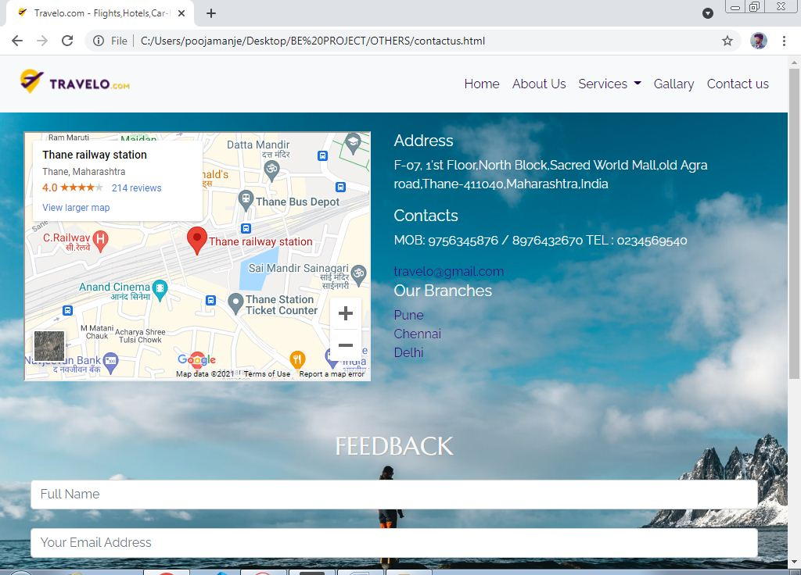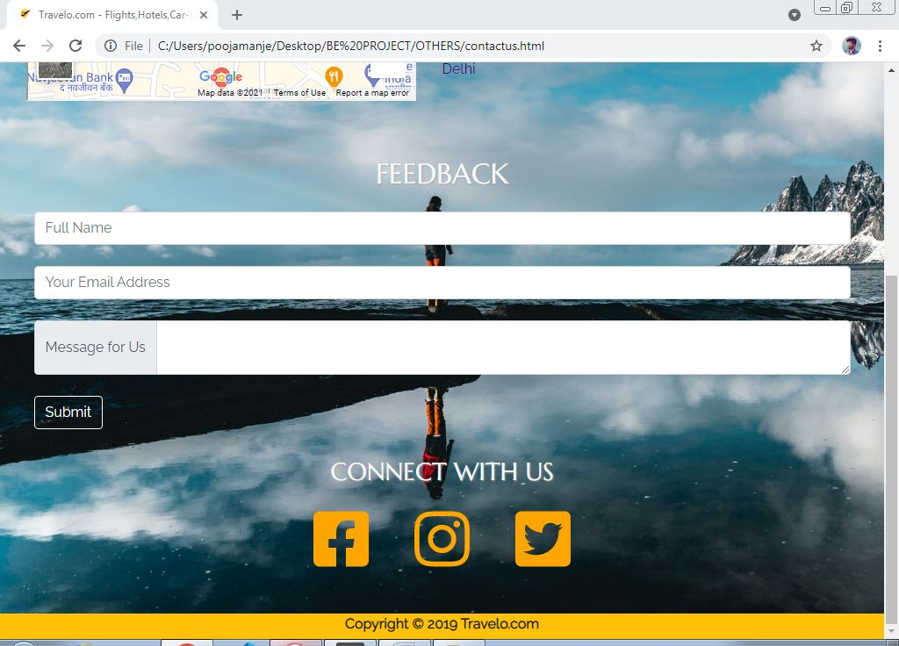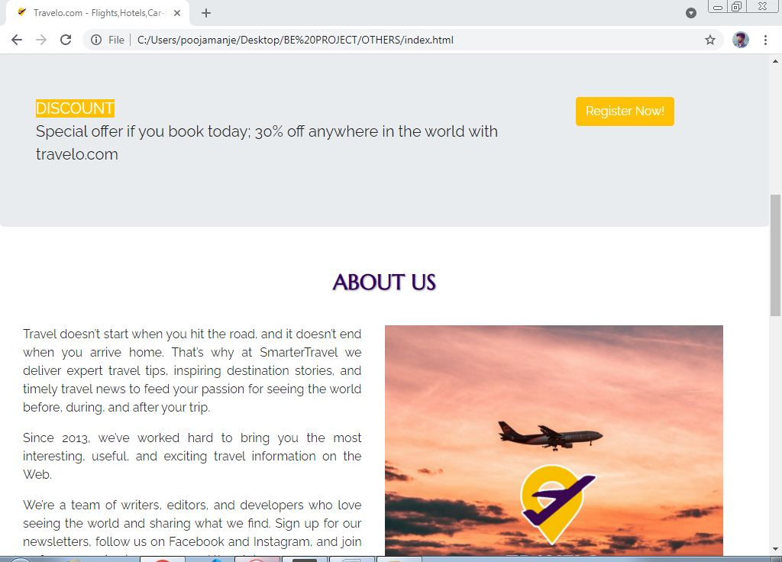



1. **ADVANTAGES**
2. Communicate with potential customers 24/7
3. Tracking of real time sales
4. Online performance management
5. Easy payment and customer support
6. **FUTURE SCOPE**

Online travel booking systems has truly transformed the way people plan their tours along with how travel agencies all over the world offer their services to the individual. In earlier times, local tour operators and travel agencies were totally dependent on the travel needs and requirements of the people who are present nearby. Their services were limited to a particular geographical area, which also restricts their profits and revenue. Furthermore, offering the customers with full fledged travel services during the tour were quite difficult as well.

1. **CONCLUSION**



Tourism is currently recognized as a global industry which is highly growing at a high rate like other industry. There are many different activities are occurred in tour activities. My ‘Tour and travels’ web based application helps in online distribution of tour packages, hotel, hotel properties, transfer etc. This ‘Tour and travels website” can be fully customized with integration different API’s. It has friendly environment that connects customer willingly. Finally, I can say that this Web Based Application will help tour manager to control and handle the tour related activates effectively and efficiently.